# Gabrielle Maitland

CS 255 Systems Analysis and Design

# CS 255 System Design Document

## UML Diagrams

### UML Use Case Diagram

This Use Case diagram includes functions that are mentioned in the DriverPass transcript. The actors would include the secretary, instructor, customer, IT admin Ian, and company admin Liam. Some of the use cases include registration, appointment modification, viewing progress, managing user access, and downloading reports.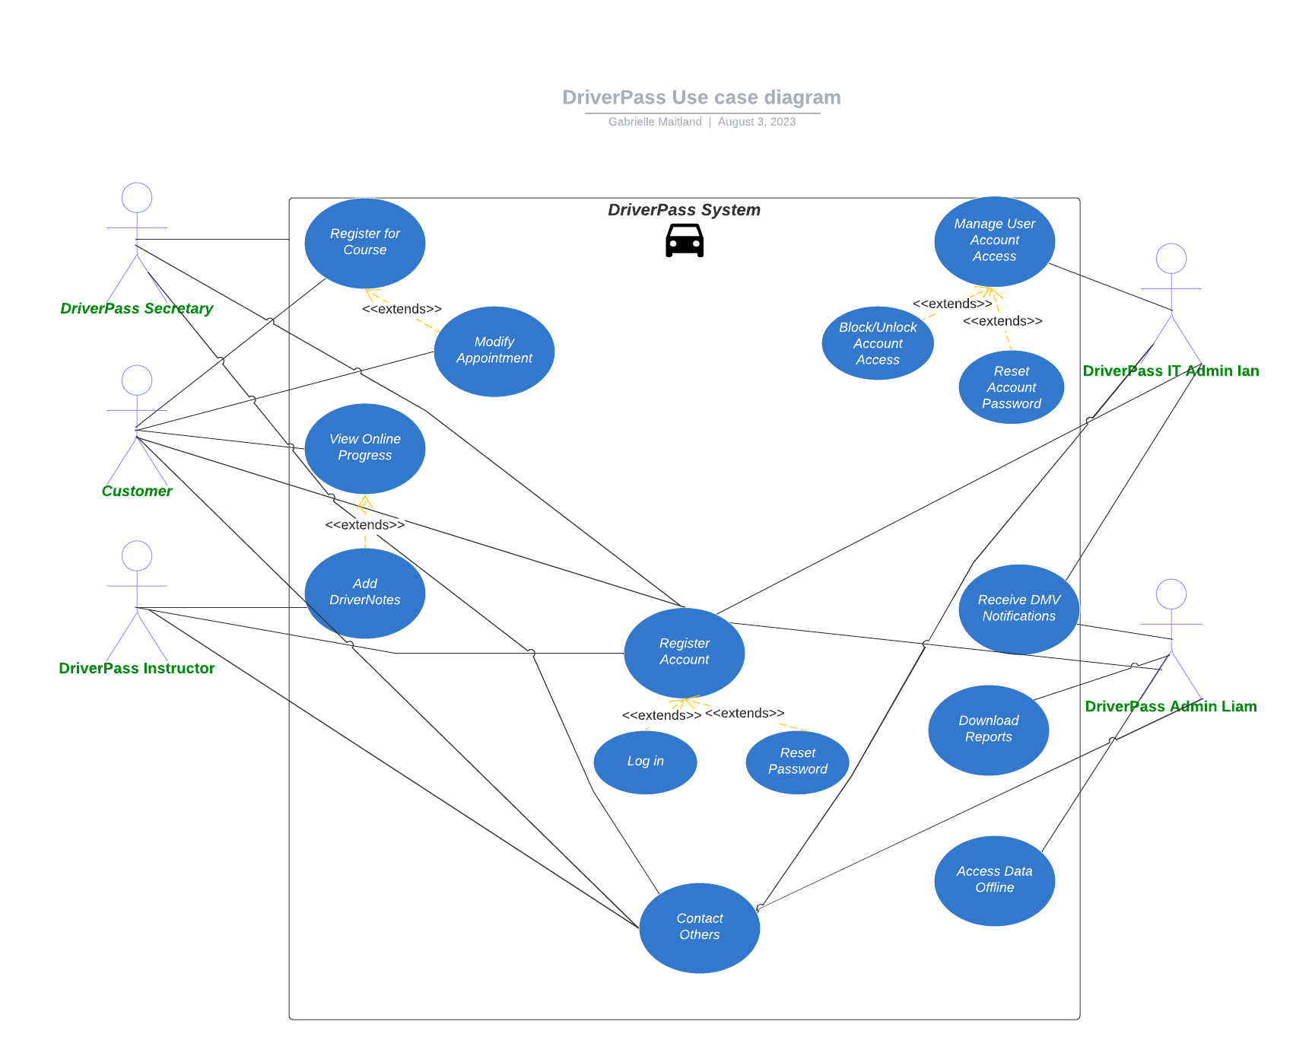

### UML Activity Diagrams

These diagrams detail two use cases, one being course registration and the other being account access management. The course registration diagram explores the process of a user enrolling and paying for a course. It includes a branch that checks whether a user is registered or not. If they are registered, they will be rerouted to modify their existing appointment. If not, they will have to enroll, pay, and book an appointment.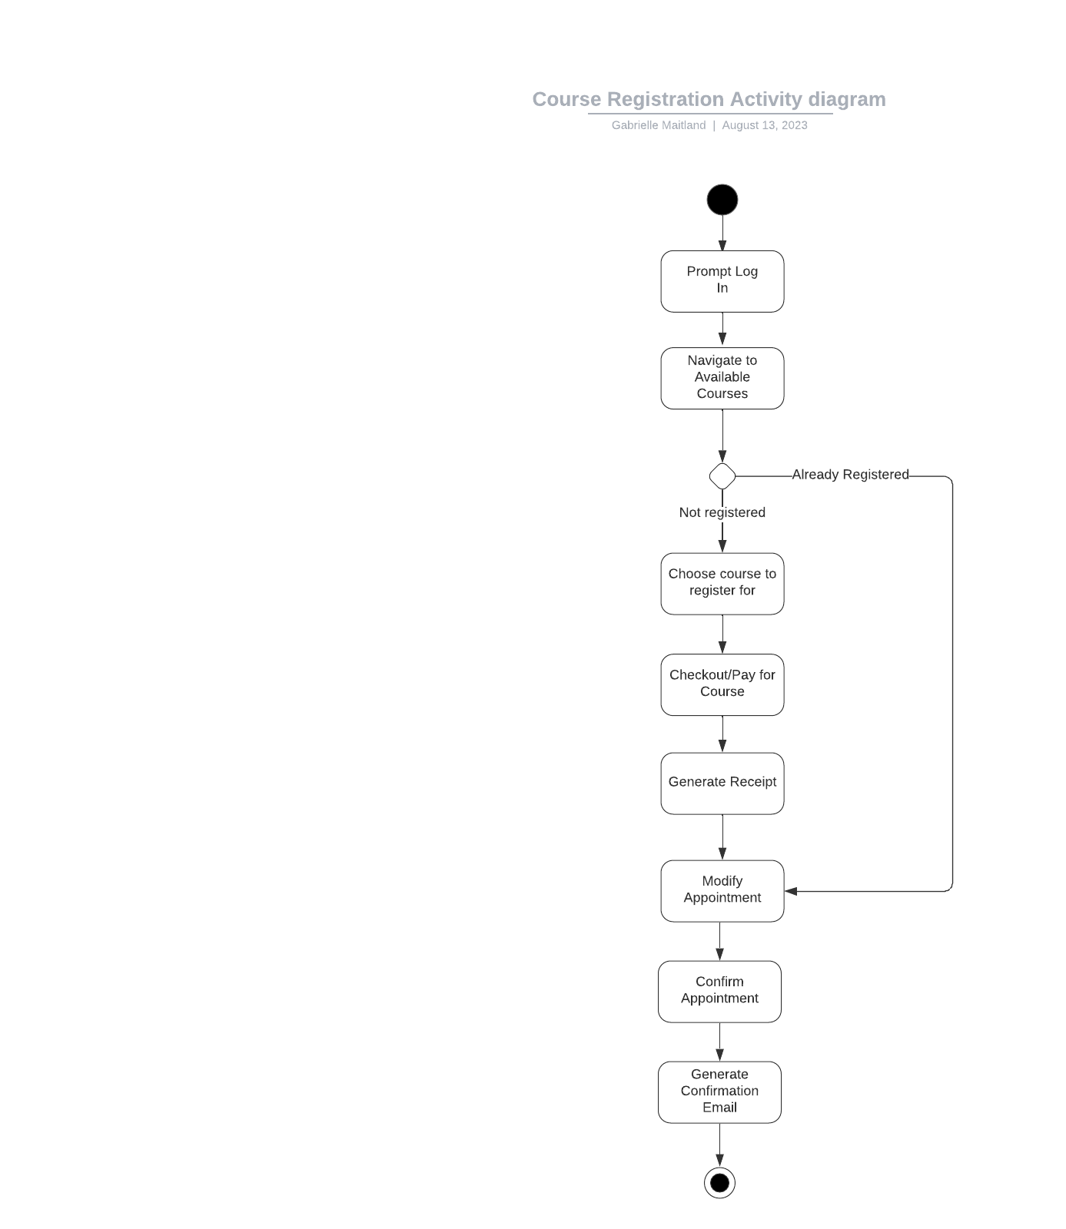

To manage account access, the user must navigate to the proper page, which in this case is titled Tools. The system would validate the privileges of the user in a branch. If the user has insufficient privileges, it means that they do not have access to manage the accounts of users other than themselves. However, should they have the proper privileges, they continue down the path that allows them to lookup users, block or unlock their account, and reset their password to a randomly generated code.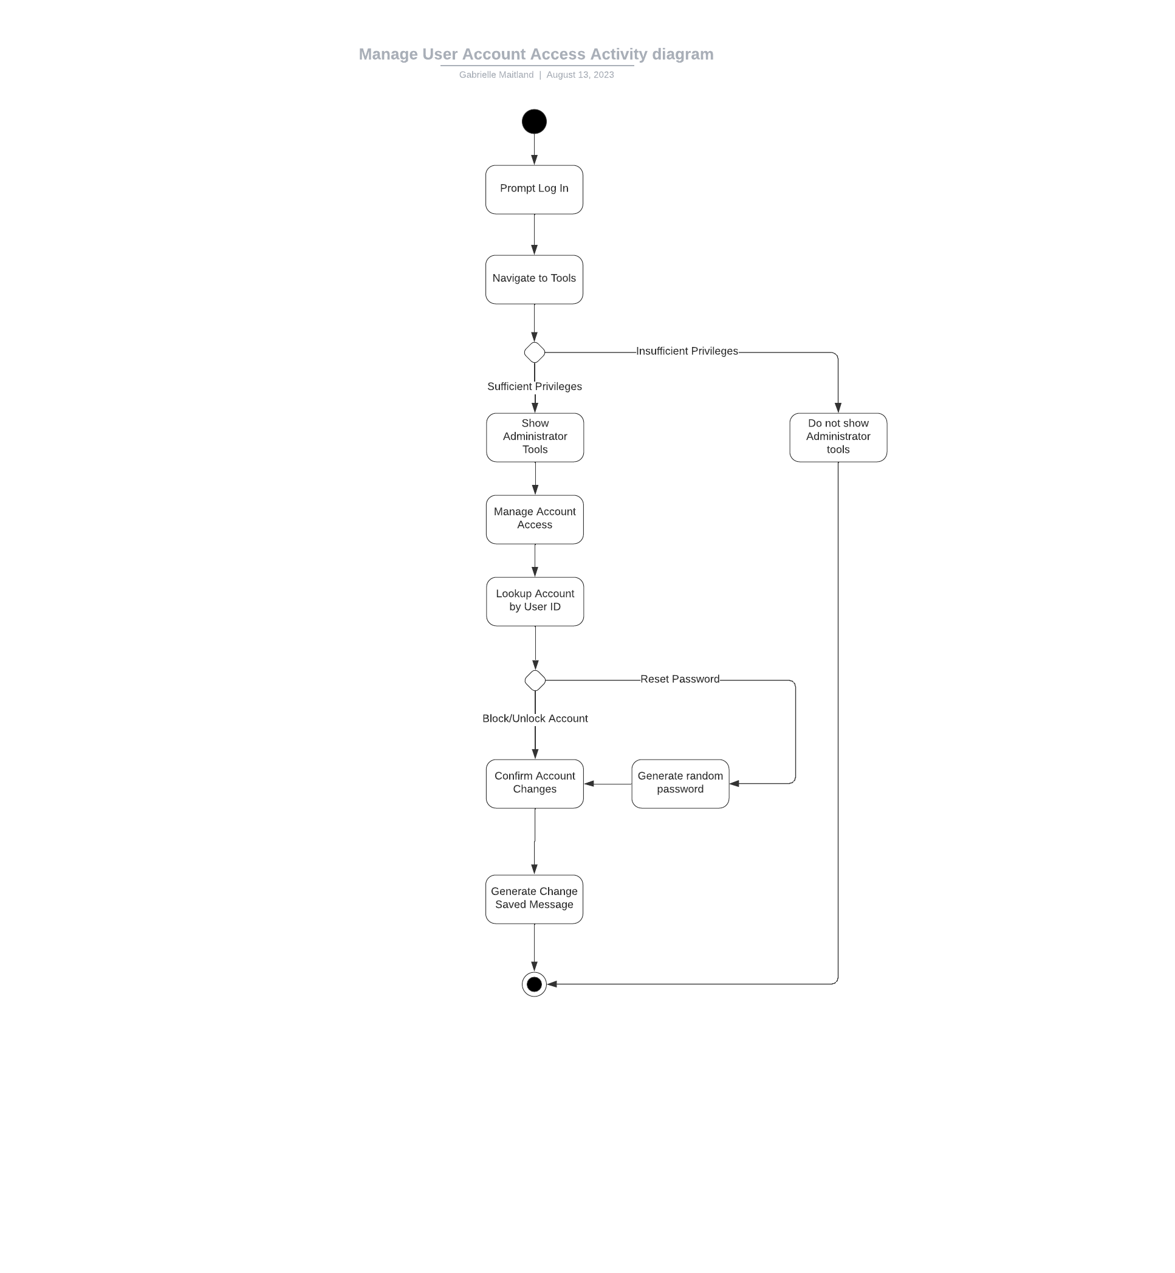

### UML Sequence Diagram

The sequence diagram gives us a different kind of visual of the course registration process we viewed in the activity diagram. In this instance, we are able to view the validation layer of the site. We can also see what specific information is accessible in the database, and what we would need to store in specific instances.

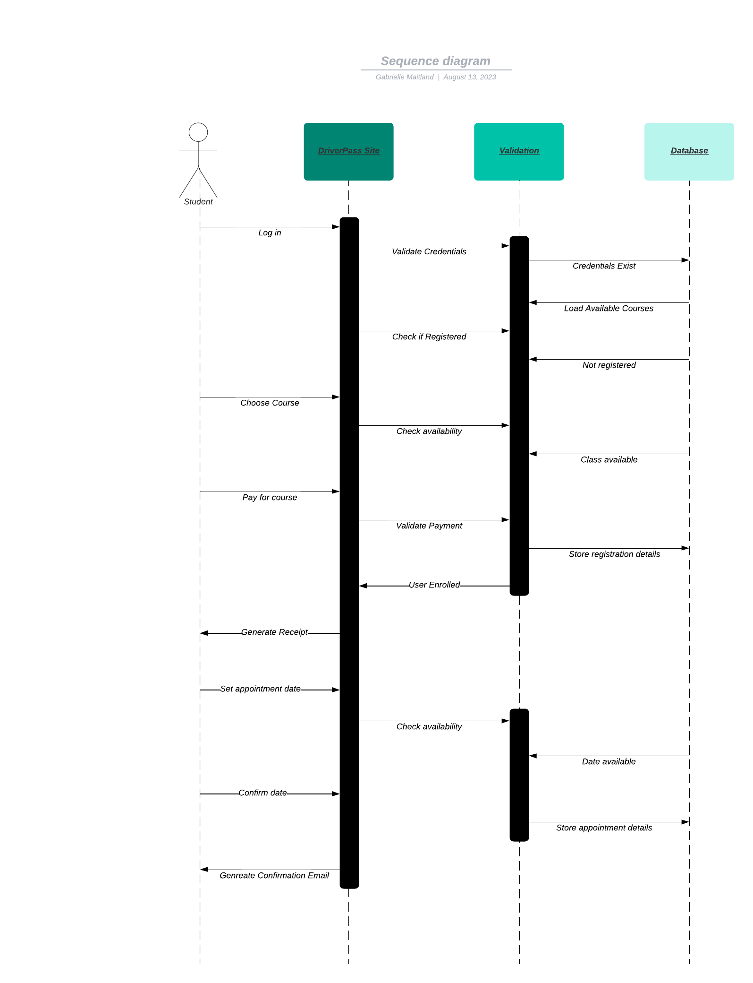

### UML Class Diagram

*Our class diagram helps us to view the relationships between each component of the DriverPass system. We include classes for the User, Courses, Progress, and Notes. Specific user classes of Ian, Liam, the Secretary, Instructor, and Customer each inherit from the User class. These specific classes also have their own unique attributes and functions depending on their access level. This also applies to the non-user classes.*

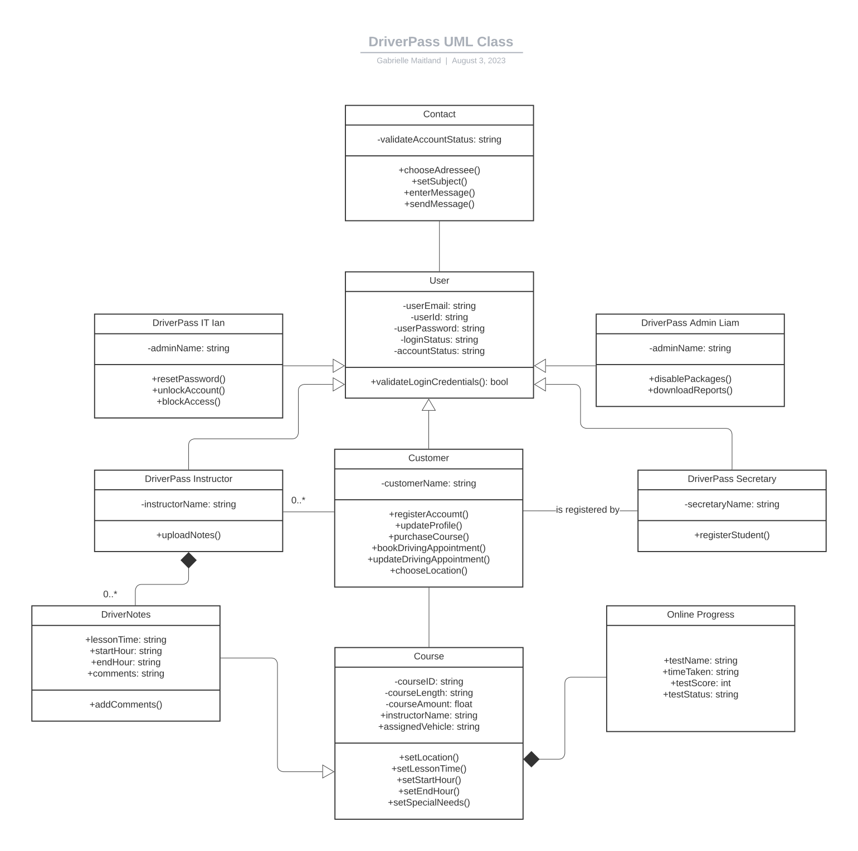

## Technical Requirements

**The technical requirements of this system would include:**

* A gateway to process customer payment
* A secure cloud database to backup user progress and store site reports
* Robust security features to deter hacking attempts, such as encryption, locking account on x amount of failed log ins, two factor authentication if the users so chooses, etc.
* A web application and a mobile application
* Compatibility between different devices and platforms
* Performance and Scalability to manage large influxes of customers, meaning there should be very little delay in viewing live updates, and virtually no lag when navigating the site/application